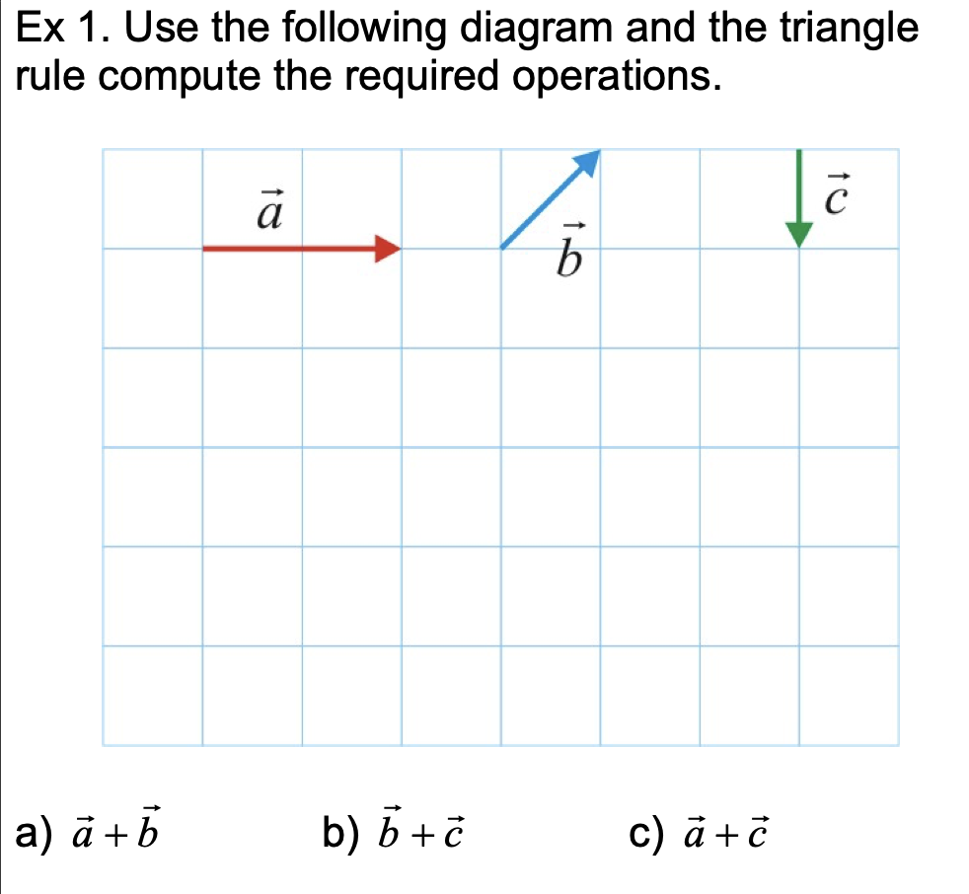

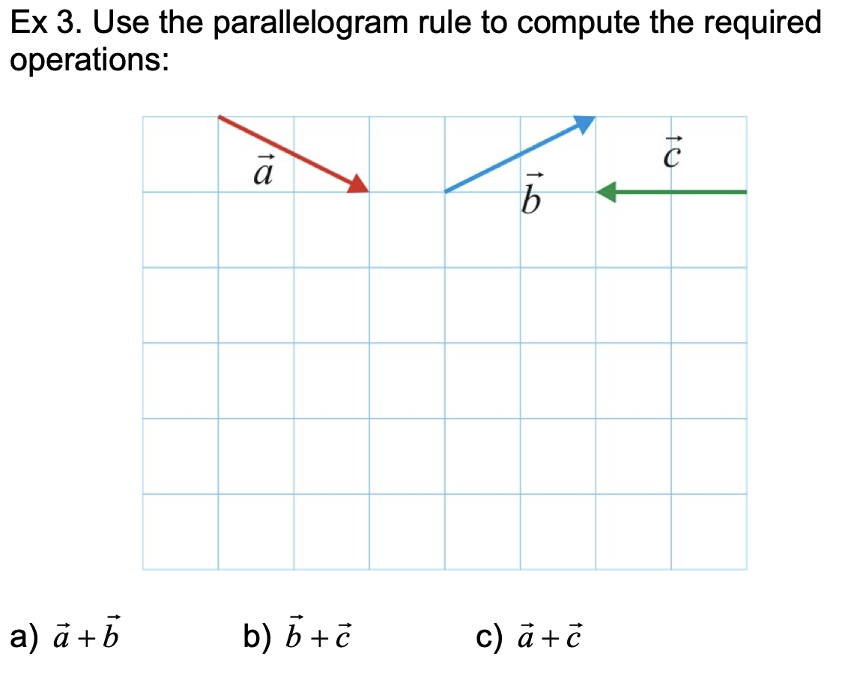

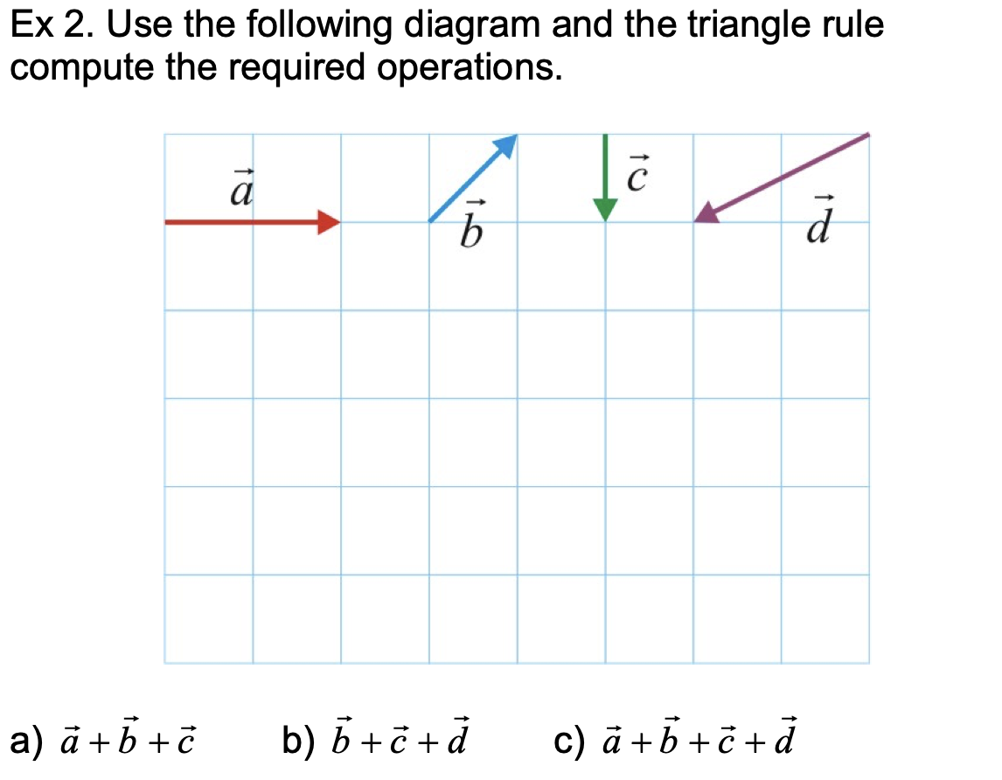

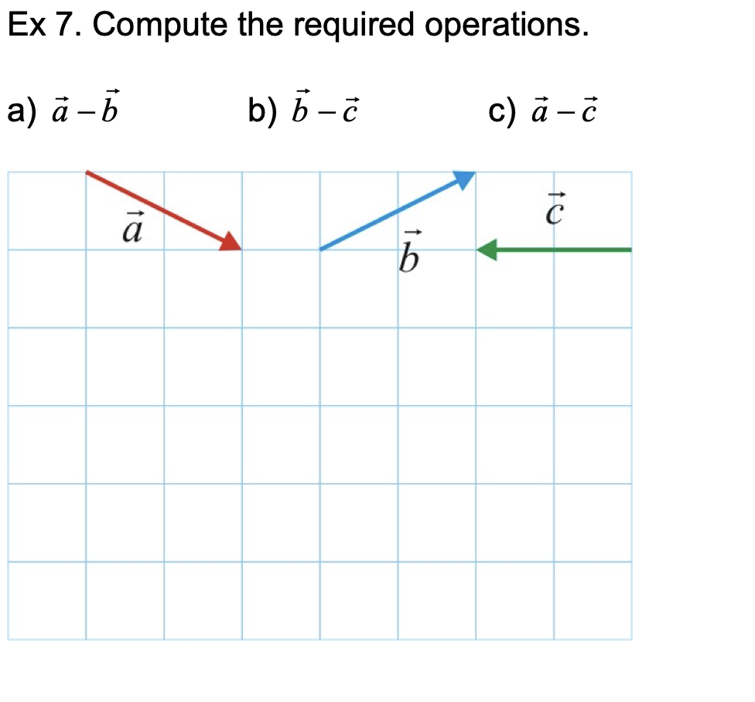

Consider following vectors:

$$a=\left(\begin{matrix}-3 \\ -5\end{matrix}\right) b=\left(\begin{matrix}3 \\ 7\end{matrix}\right) c=\left(\begin{matrix}7 \\ -1\end{matrix}\right) d=\left(\begin{matrix}4 \\ -4\end{matrix}\right)$$

Please work out each of the equations below and graph each operation:

1. **a – b**
2. **a – c**
3. **a – d**
4. **c – d**
5. **b – c - a**
6. **c – a – d**